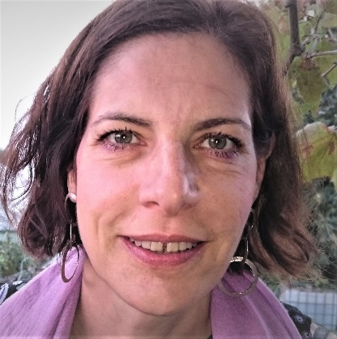

Zoe Kardasiadou

Dr Zoe Kardasiadou is a lawyer by education and has worked in the field of ICT law and data protection since more than 20 years. Her doctoral thesis dealt with product liability and medical malpractice for medical expert systems.
She joined the Data Protection Unit at the Commission, DG JUST one year ago, seconded from the Greek data protection authority. Before her current position, she worked as legal officer at the EDPB, EDPS and the EU Fundamental Rights Agency.
At the Commission she mostly focuses on data protection in law enforcement, including on AI and data protection, and on privacy in electronic communications.
Zoe worked for 10 years at the Greek data protection authority, inter alia as Head of Department for policy and supervision.

